**GLOBAL PLASTIC POLLUTION ANALYSIS**

A Project Report

submitted in partial fulfillment of the requirements

of

ARTIFICIAL INTELLIGENCE AND MACHINE LEARNING CERTIFICATE

by

**HARISH KM, 1VE20CS047**

**C N DILIP KRISHNA, 1VE20CS026**

**ADARSH M, 1VE20CS003**

**APPU ANNAVERAPPA, 1VE20CS019**

**BHAGYALAXMI SHEELVANT 1VE20CS022**

Under the Esteemed Guidance of

**SHILPA HARIRAJ**

**ACKNOWLEDGEMENT**

We would like to take this opportunity to express our deep sense of gratitude to all individuals who helped us directly or indirectly during this thesis work.

Firstly, we would like to thank my supervisor, SHILPA HARIRAJ for being a great mentor and the best adviser I could ever have. His advice, encouragement and critics are source of innovative ideas, inspiration and causes behind the successful completion of this dissertation. The confidence shown on me by him was the biggest source of inspiration for me. It has been a privilege working with him from last one year. He always helped me during my thesis and many other aspects related to academics. His talks and lessons not only help in thesis work and other activities of college but also make me a good and responsible professional.

#### ABSTRACT

*This abstract summarizes a global analysis of plastic pollution. Assessing the pervasive issue, the study explores the environmental impact, socioeconomic consequences, and mitigation strategies. Utilizing comprehensive datasets, the research identifies key contributors to plastic pollution, highlighting geographical hotspots and the ecological ramifications. Additionally, it examines emerging technologies and policy interventions aimed at curbing plastic waste. The findings provide valuable insights for policymakers, environmentalists, and industries to collaboratively address this urgent global challenge, fostering sustainable practices and promoting a circular economy to mitigate the detrimental effects of plastic pollution on ecosystems and human well-being.*

**TABLE OF CONTENTS**

Abstract 3

**Chapter 1.**  **Introduction**  **5**

1.1 Problem Statement 6

1.2 Problem Definition 6

1.3 Expected Outcomes 7

**Chapter 2.**  **Literature Survey**  **8**

2.1 Paper 1 9

**Chapter 3.**  **Proposed Methodology** 10

3.1 System Design 11

3.2 Modules Used … 12

3.3 Advantages ……………………………………………………………………………………………………. 12

3.4 Requirement Specification ……………………………………………………………………………. 13

**Chapter 4.**  **Implementation and Results**  15

5.1. Output 16

**Chapter 5.**  **Conclusion**  17

**GitHub Link...................................................................................................................... 19**

**References** **…. 19**

**CHAPTER 1**

**INTRODUCTION CHAPTER 1**

**INTRODUCTION**

This summarizes a global analysis of plastic pollution. Assessing the pervasive issue, the study explores the environmental impact, socioeconomic consequences, and mitigation strategies. Utilizing comprehensive data sets, the research identifies key contributors to plastic pollution, highlighting geographical hotspots and the ecological ramifications. Additionally, it examines emerging technologies and policy interventions aimed at curbing plastic waste. The findings provide valuable insights for policymakers, environmentalists, and industries to collaboratively address this urgent global challenge, fostering sustainable practices and promoting a circular economy to mitigate the detrimental effects of plastic pollution on ecosystems and human well-being.

1. **Problem Statement:**

The world faces a critical challenge with the escalating issue of plastic pollution, characterized by the widespread and persistent contamination of ecosystems. This crisis not only poses a severe threat to biodiversity and ecosystems but also has far-reaching socio-economic consequences. As plastic pollution transcends geographical boundaries, a comprehensive understanding of its sources, distribution, and impact is essential. Urgent action is required to identify and implement effective strategies that address the root causes and mitigate the detrimental effects of plastic pollution on the environment and human well-being.

1. **Problem Definition:**

The problem at hand involves the global and pervasive challenge of plastic pollution, this has resulted in widespread environmental degradation, threatening ecosystems, wildlife, and human health. Consequently, there is an urgent need to define and implement effective solutions that encompass source reduction, improved waste management, and sustainable alternatives, aiming to curtail the adverse impact of plastic pollution on a global scale

1. **Expected Outcomes:**

The expected outcomes collectively aim to create a global environment where the adverse effects of plastic pollution are significantly mitigated, fostering a sustainable and resilient future for ecosystems and human societies alike.

**CHAPTER 2**

**LITERATURE SURVEYCHAPTER 2**

**LITERATURE SURVEY**

1. **Paper-1**

Plastic analysis GRP

**Brief Introduction of Paper:**

The elastic design, also known as the allowable stress method (or Working stress method), is a traditional design method based on steel's elastic properties. This design approach restricts the material’s structural usefulness to a certain permissible tension, which is far below the elastic limit. Working load stresses must not surpass the prescribed permissible stresses, which are calculated by multiplying the yield stress of steel by an appropriate factor of protection. Beyond the elastic stress, the elastic design does not take into account the material's strength. As a result, structures built using this approach will be heavier than structures designed using plastic methods; but, in many situations, elastic construction will require less stability bracing. The ultimate load, rather than the yield stress, is used as the design criterion in the plastic design of a structure. The word "plastic" came about because the ultimate load is determined by the strength of steel in the plastic range. This approach is also known as the ultimate load design method or load factor design method. In this process, the steel's strength beyond the yield stress is completely exploited. This method is fast and offers a logical approach to structure analysis. Since the parts created by this method are smaller in size than those created by the elastic construction method, it also saves a significant amount of steel weight. The key application of the plastic design approach is the study and design of statically indeterminate framed structures.

**CHAPTER 3**

**PROPOSED METHODOLOGYCHAPTER 3**

**PROPOSED METHODOLOGY**

* 1. **System Design**
     1. **Data Collection and Analysis:**

Establish a global database to collect and analyze data on plastic pollution sources, distribution, and environmental impact. Implement advanced data analytics to identify trends, hotspots, and key contributors.

**3.1.2 Technology Integration:**

Integrate cutting-edge technologies for plastic waste collection, sorting, and recycling. Develop a technology roadmap for continuous innovation and adoption.

* 1. **Modules Used**

**Data Flow Diagram**

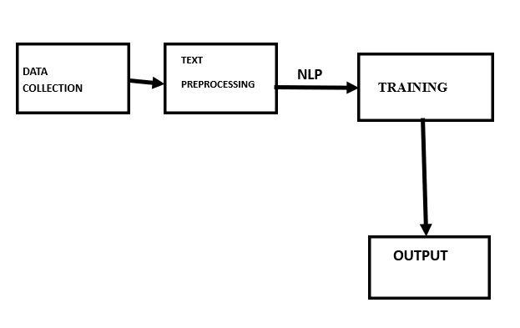

* 1. **Advantages**
  + Enables thorough data analysis for informed decision-making.
  + Facilitates effective collaboration among diverse stakeholders globally.
  + Establishes and enforces consistent international regulatory standards.
  + Integrates cutting-edge technologies for efficient plastic waste management.
  + Utilizes a global awareness platform to encourage responsible consumer behavior.
  + Tests and refines strategies through evidence-based pilot programs.
  + Improves waste management infrastructure, particularly in high-pollution regions.
  + Designs and delivers training programs for communities and industries.
  + Implements a real-time monitoring and evaluation system for timely feedback.
  + Establishes a secure digital platform for global collaboration and information exchange.
  + Develops guidelines for scaling successful initiatives globally.
  + Establishes innovative financing mechanisms to support large-scale projects.
  + Implements a legal framework for addressing plastic pollution on a global scale.
  + Integrates plastic pollution mitigation into broader climate resilience initiatives.
  1. **Requirement Specification**
     1. **Hardware Requirements:**
* CPU: Utilized for data processing and model training.
* RAM: Required for handling and manipulating large datasets during analysis and modeling.
* Storage: Used to store the datasets and code files required for analysis.
* GPU (if available): Sometimes employed to expedite computations in machine learning processes, especially for large datasets and complex models.

**Software Requirements:**

* Python: Utilized for coding and implementing machine learning models.
* Scikit-learn: Employed for implementing classification algorithms like Logistic Regression, Naive Bayes, Decision Tree, Random Forest, AdaBoost, SVM, Linear Discriminant Analysis, MLP, and K-Nearest Neighbors.
* Pandas and NumPy: Used for data manipulation and analysis.
* Principal Component Analysis (PCA): Applied for feature reduction and optimization.
* Jupyter Notebooks: Utilized as an interactive environment for analysis and code execution.
* Matplotlib and Seaborn: Used for data visualization and result interpretation.

**CHAPTER 4**

**Implementation and Result**

**CHAPTER 4**

**IMPLEMENTATION and RESULT**

**Output:**

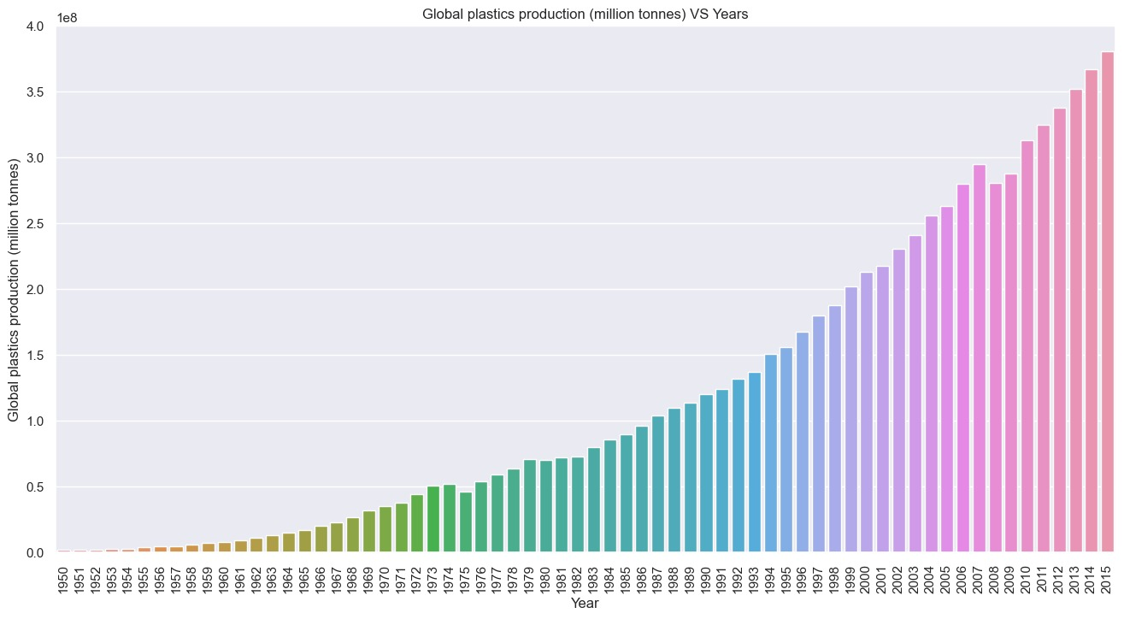

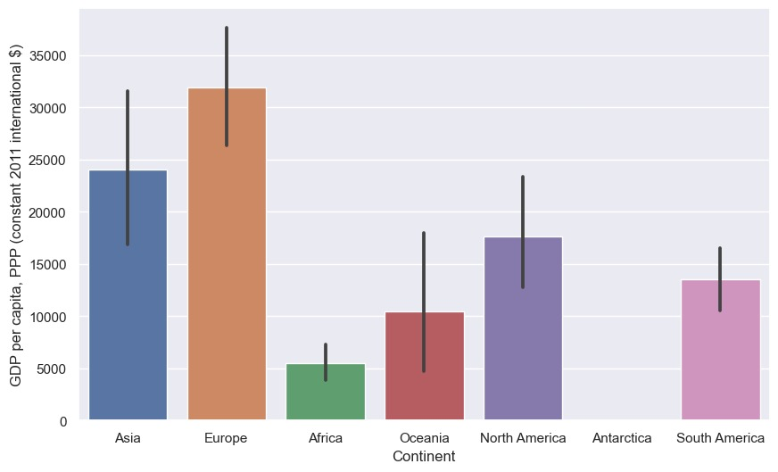

**CHAPTER 5**

**CONCLUSIONCHAPTER 5**

**CONCLUSION**

In conclusion, the proposed system for global plastic pollution mitigation presents a comprehensive and forward-thinking approach to address the urgent environmental challenge posed by plastic pollution. By leveraging data-driven insights, international collaboration, and innovative technologies, the system aims to tackle the root causes of plastic pollution at a global scale. The inclusion of pilot programs, real-time monitoring, and adaptive management ensures the continuous refinement of strategies for maximum effectiveness. The emphasis on public awareness, stakeholder engagement, and a secure global collaboration platform reflects a commitment to inclusivity and transparency. As this system is implemented, it holds the potential to significantly reduce the impact of plastic pollution on ecosystems, biodiversity, and human well-being, fostering a more sustainable and resilient future for the planet.

**REFERENCES**

Datasets: Kaggle

<https://www.kaggle.com/datasets/sohamgade/plastic-datasets>

GitHub:

https://github.com/adarsh852/microsoft-edunet